**Data Information**

**Measures of Central Tendency**

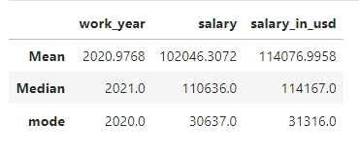

**Salary Distribution**

1. The large difference between the mean ($102,046) and median ($110,636) salaries suggests a skewed distribution, with some very low salaries.

2. The mode ($30,637) is significantly lower than the mean and median, indicating a potential entry-level or junior salary cluster.

3. The median salary in USD ($114,167) is close to the mean ($114,077), suggesting a relatively stable exchange rate.

**Work Year Distribution**

1. The mean (2020) and median (2021) work years are close, indicating a relatively uniform distribution.

2. The mode (2020) suggests a potential peak in data from that year.

**Potential Insights**

1. Industry growth: The data may indicate a growing industry with increasing salaries.

2. Geographic differences: Salary variations could reflect differences in cost of living or regional economies.

3. Experience levels: The salary distribution may represent various experience levels, with entry-level salaries (mode) and more senior roles (mean and median).

4. Currency fluctuations: The similarity between salary and salary in USD suggests stable exchange rates.

**Percentile**

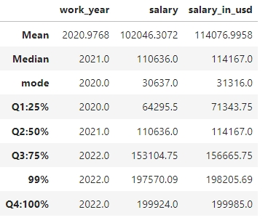

**1. Salary growth rate:** Approximately 50% increase from Q1 to Q3, indicating significant salary growth.

**2. Skewness:** Salary distribution is right-skewed, with higher salaries more spread out.

**3. USD conversion stability:** Salary in USD values closely track original salaries, indicating stable exchange rates.

**4. Recent data dominance:** Most data points are from 2021 and 2022, indicating a focus on recent salary trends.

**5. Top-end salaries:** 99th percentile salaries are nearly double the median, indicating high-end salary outliers.

**6. Consistency across percentiles**: Salary and Salary in USD values show consistent growth across percentiles.

**7. Potential industry differences:** Salary variability may indicate industry-specific differences.

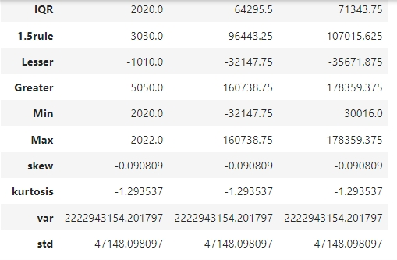

1**. Salary growth**: The maximum salary in 2022 is significantly higher than the median salary (not shown).

2. **Industry competitiveness**: High salaries may indicate a competitive industry with high demand.

3. **Global consistency**: Similar skewness values for Salary and Salary in USD suggest consistent global salary trends.

4. **Data quality**: Skewness values close to 0 indicate relatively normal distributions.